INSTRUCTIONS TO Use Apollo:

The web instance of Apollo is running at http://162.243.149.53:8887

Apollo User Guide: http://genomearchitect.github.io/users-guide

TANVEER ANWAR SALIM chr8: 700,001..795,000 MCGJ.8.6 MCGJ.8.6

LOGIN INFORMATION APOLLO

----------------------------------

INSTRUCTIONS:

1. Be sure the right of your genetic engine says

"Valley Oak"

2. Paste chr8 700,001..795,000 into the Annotator search

engine http://162.243.149.53:8887/annotator/index

and enter "Go".

3. Choose one of the genes in the "Annotations"

section to your right. CLICK "Go to Annotation"

4. Find the purple bars that look like this:

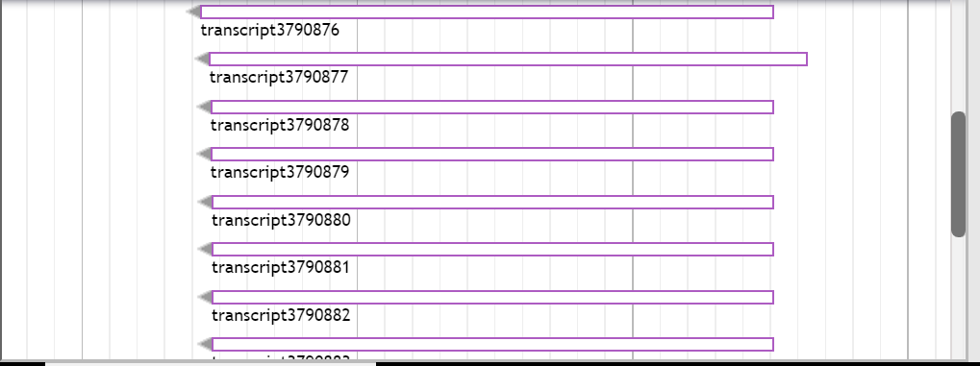

/* NCBI BLAST: Click on "PROTEIN BLAST"

The web instance of Apollo is running at http://162.243.149.53:8887

Apollo User Guide: http://genomearchitect.github.io/users-guide

TANVEER ANWAR SALIM chr8 700,001 795,000 MCGJ.8.6 MCGJ.8.6

LOGIN INFORMATION APOLLO */

----------------------------------

Drag ONE to the top:

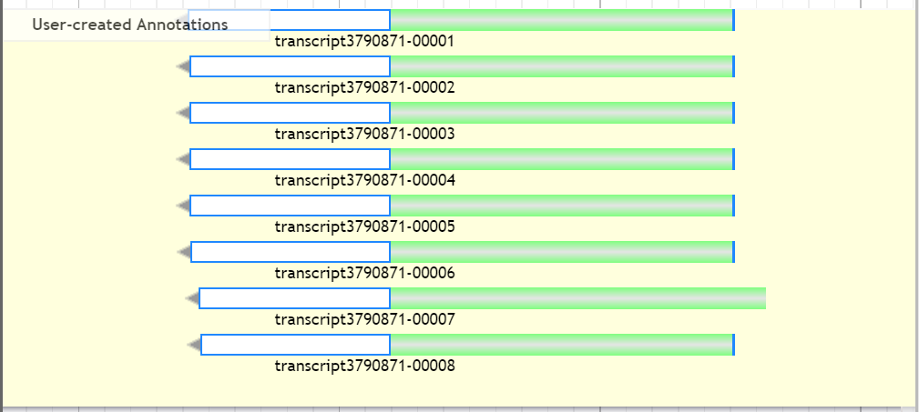

Highlight ONLY THE ONES YOU DRAGGED TO THE TOP like this:



Right click on that highlighted and click “Get Sequence”

Copy the genetic code region by using the Snipping Tool:

Make sure your name is attached to them like this:

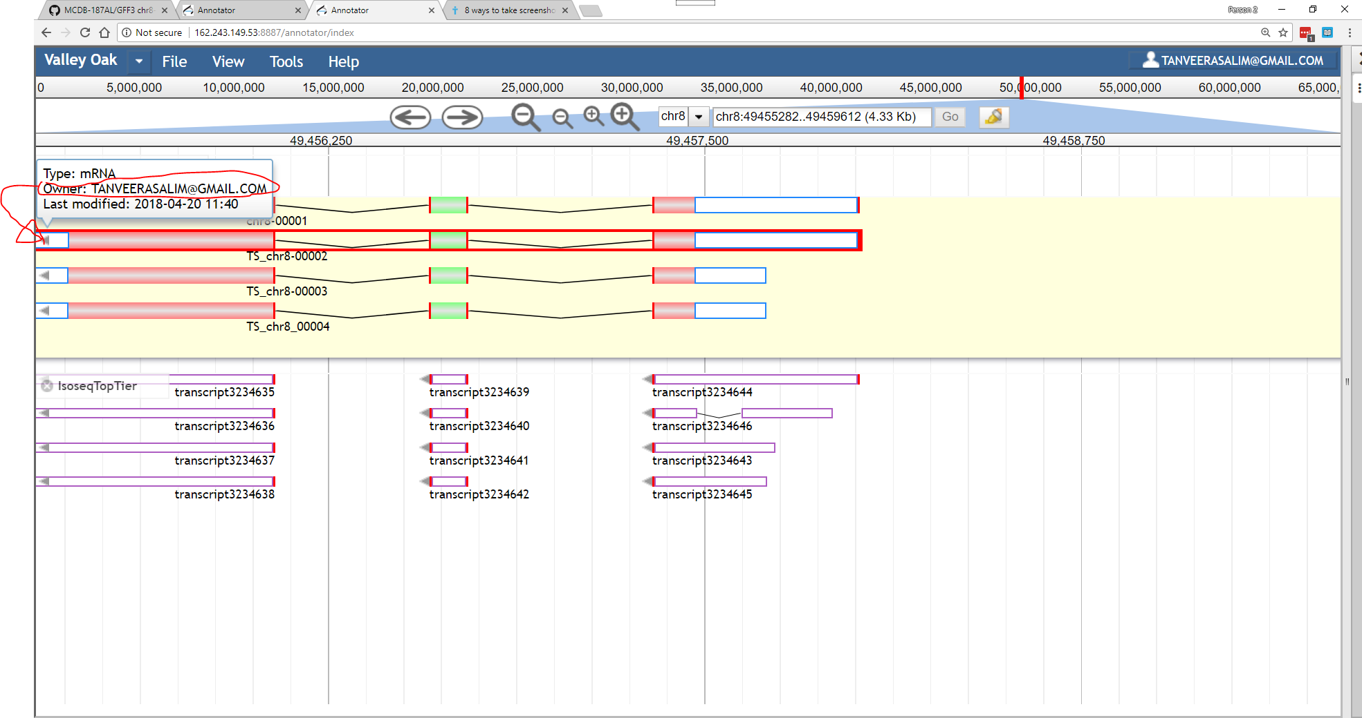

Make sure “Peptide Sequence” is highlighted

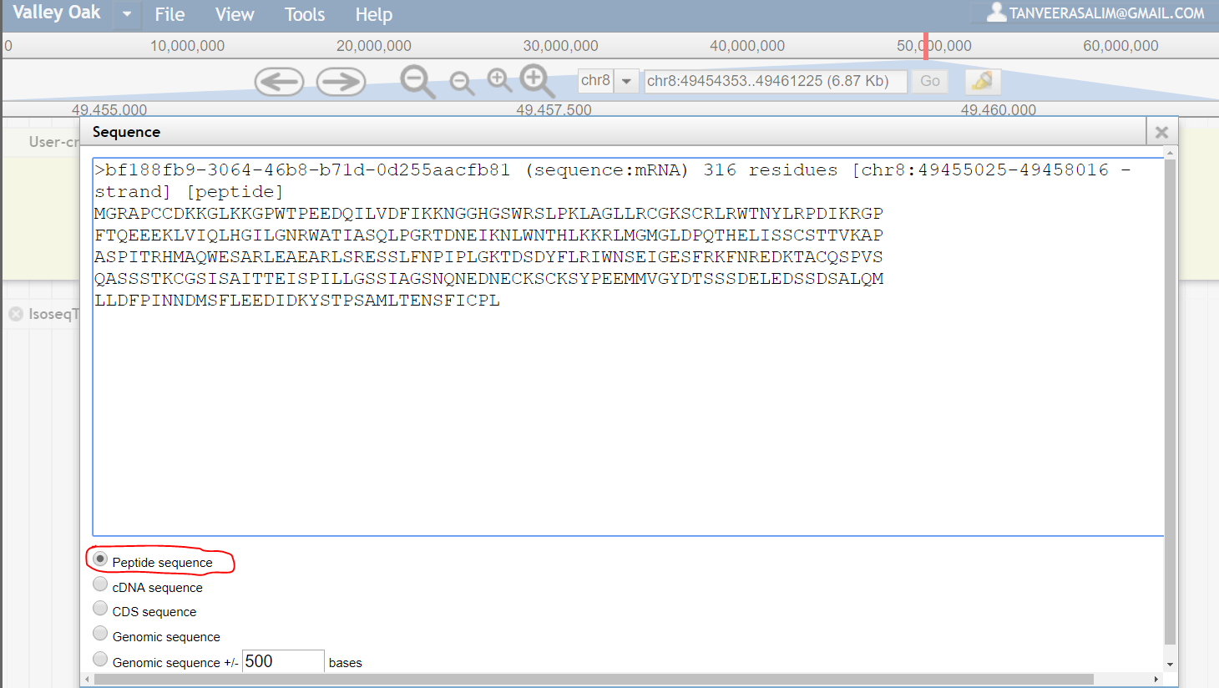

COPY the Peptide coding region using Snipping Tool and Paste it into

“Tanveer Salim MCDB 187AL Research Data”:

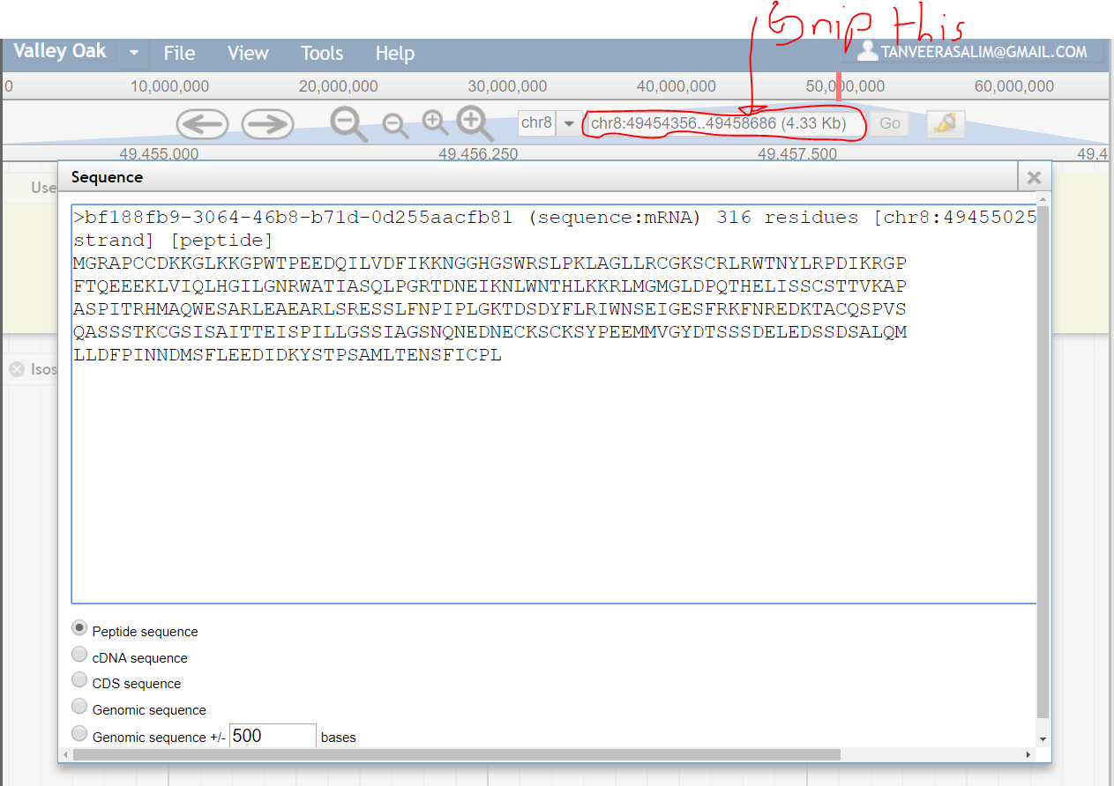

And paste it here AND Follow the Format of the following Picture for the Research Data, POINT OUT IF IT’S A GENOMIC  
OR

**PEPTIDE SEQUENCE**:

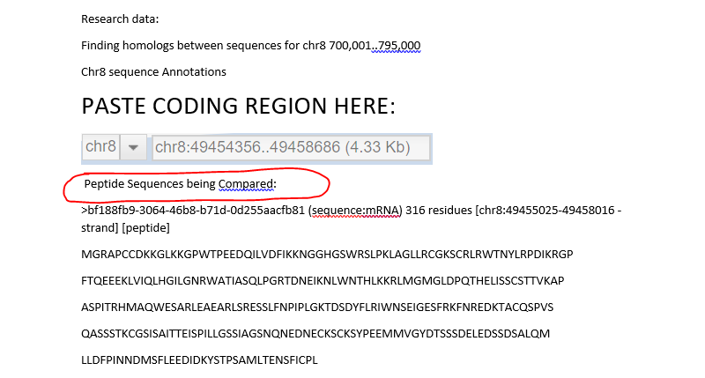

Copy EVERYTHING IN “Sequence” and paste that into the NCBI Peptide Blast.

To get to NCBI Peptide Blast:

1. Go to <https://blast.ncbi.nlm.nih.gov/Blast.cgi>

Click what is Below:

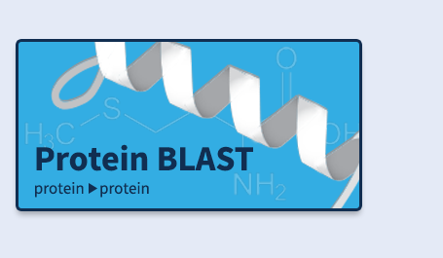

And paste it into the following box. MAKE SURE “blastp” is HIGHLIGHTED BEFORE YOU PASTE:

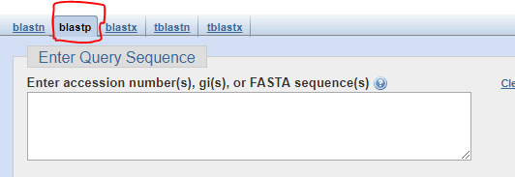

So now it looks like this:

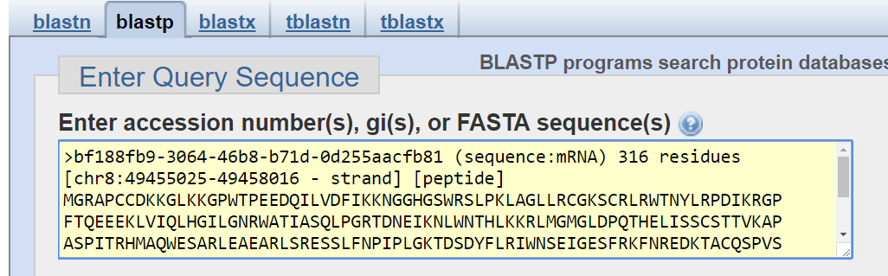

Now CLICK:



That’s this:

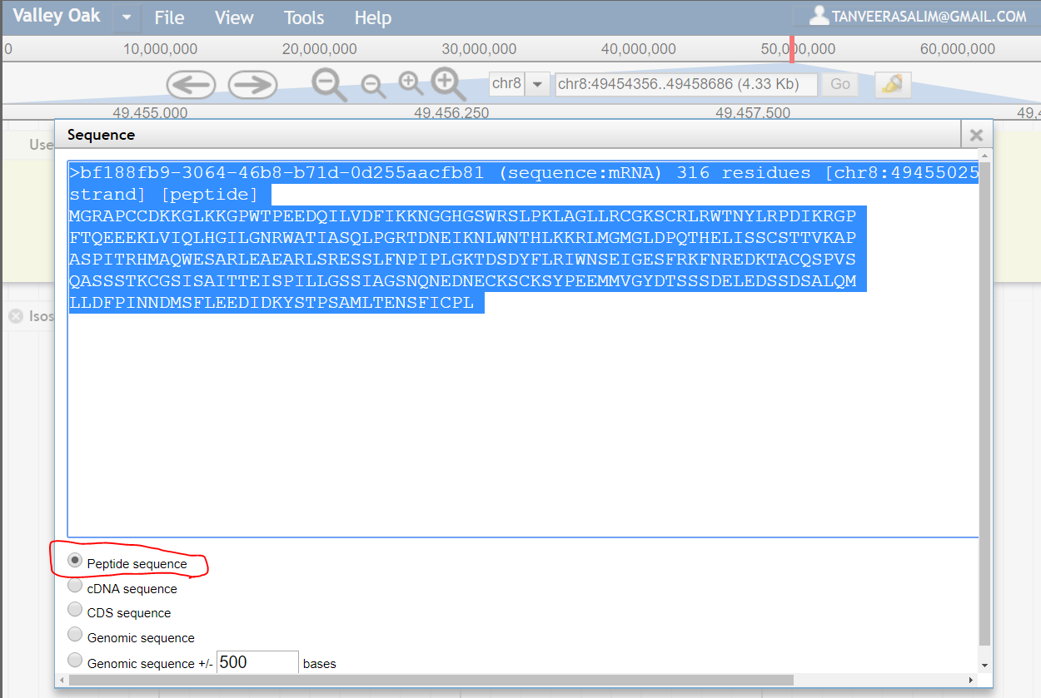

And paste it to BLAST to find protein sequence homologs like this:



WHILE NCBI BLASTp is loading, take a photo of the IsoseqTopTier Results like this:

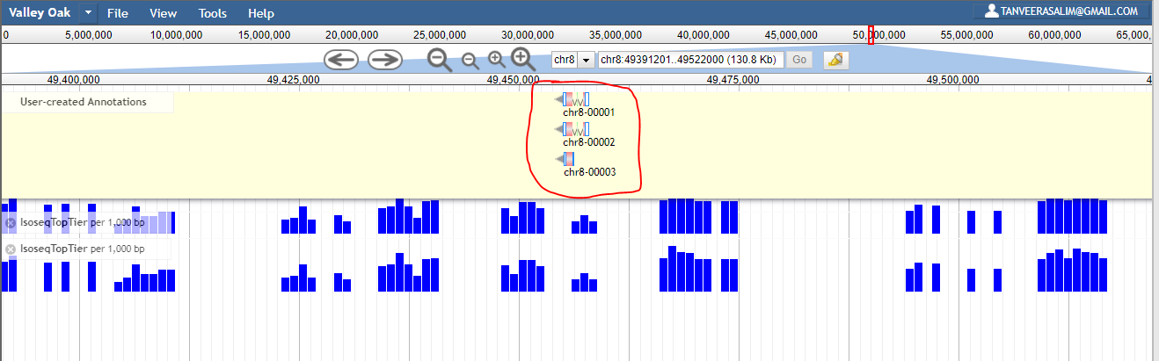

And TAKE A SECOND PHOTO of the IsoseqTopTier Results like this:

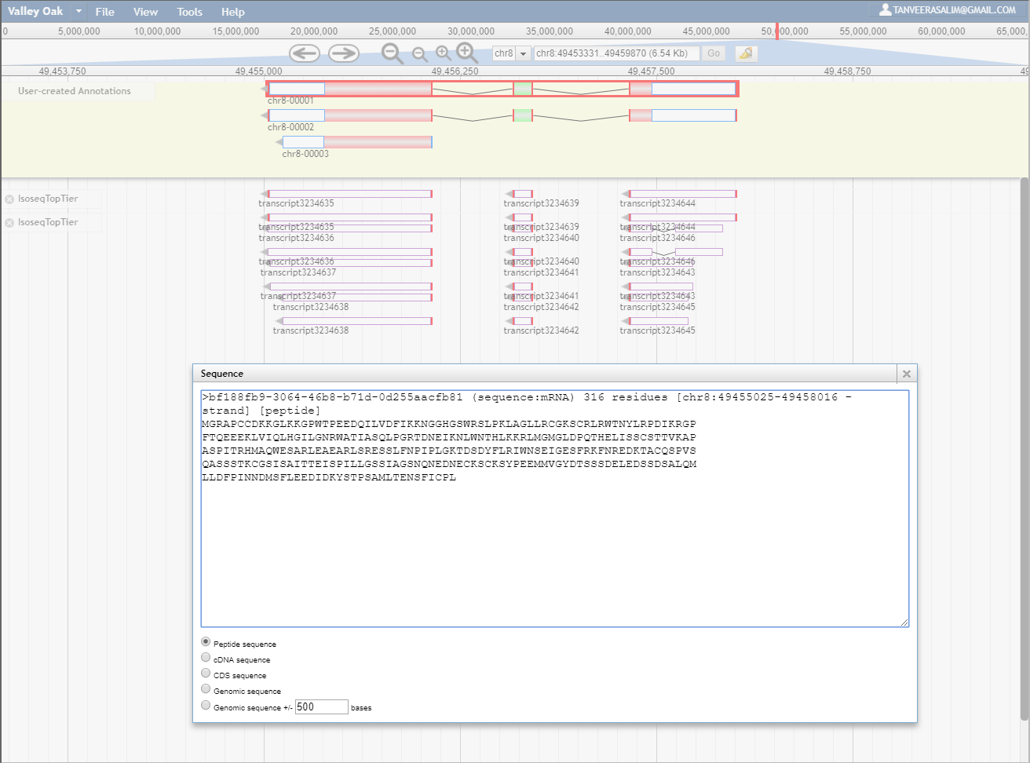

UPLOAD BOTH TO RESEARCH DATA FILE

TAKE A PHOTO OF THE COLOR KEY FOR ALIGNMENT SEQUENCES like this, save it to Research Data:

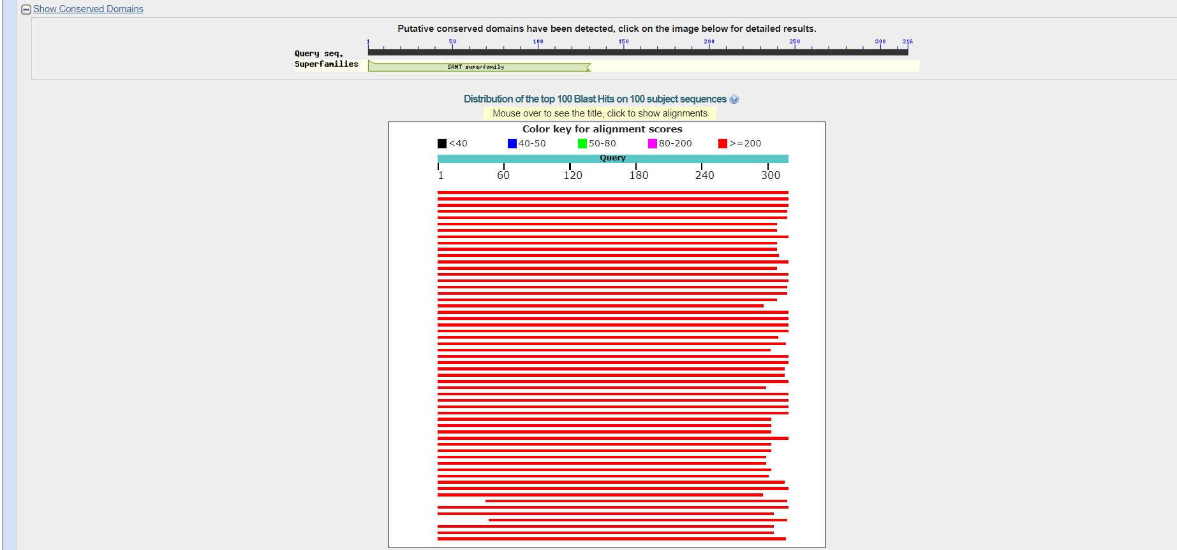

Scroll down to **Sequences producing significant alignments:**

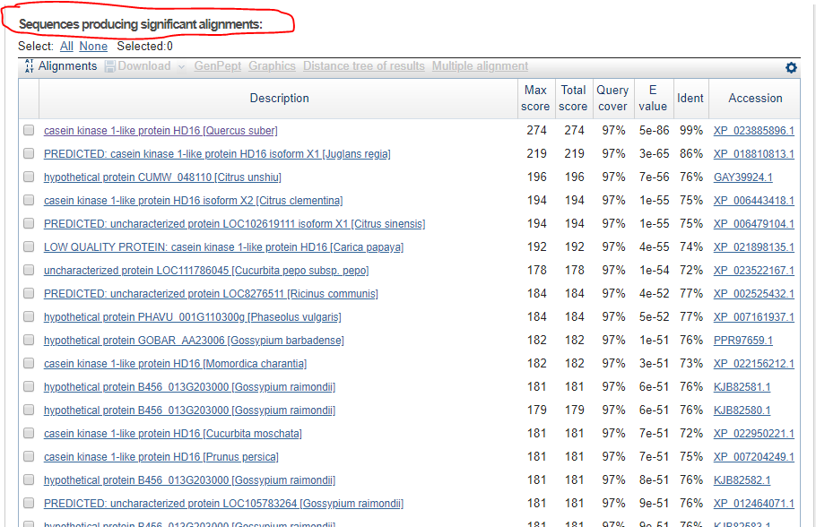

TAKE A SNAPSHOT LIKE THE PHOTO ABOVE AND ADD IT TO RESEARCH DATA FILE!

NOW SCROLL DOWN UNTIL YOU HIT THE QUERY RESULTS, TAKE A SNAPSHOT PHOTO OF THE TOP SIX RESULTS **THAT ARE EACH FROM UNIQUE** SPECIES:

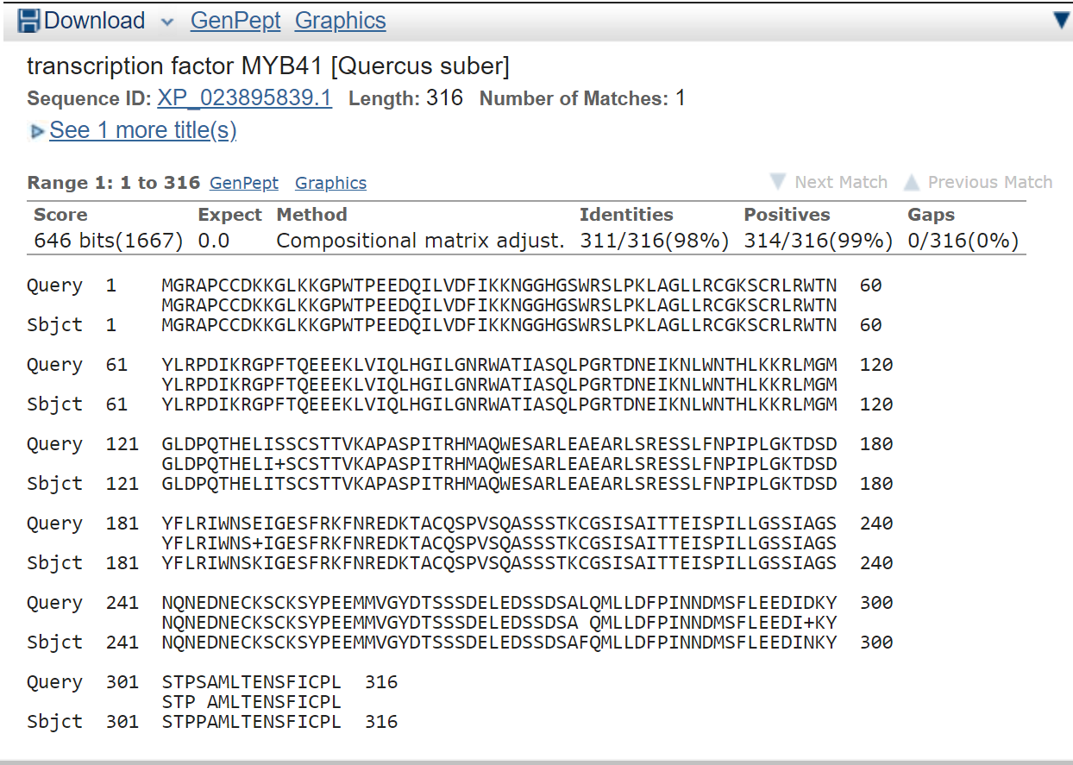

Click on the Accession link for the homolog domain you chose:



Click on FASTA:

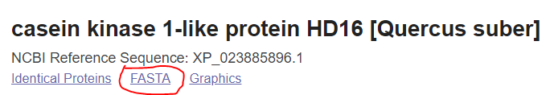

Copy that Sequence HOMOLOG to Clustal Omega:

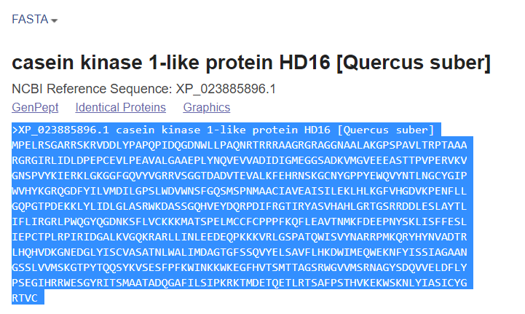

And paste the sequence below the first like this:

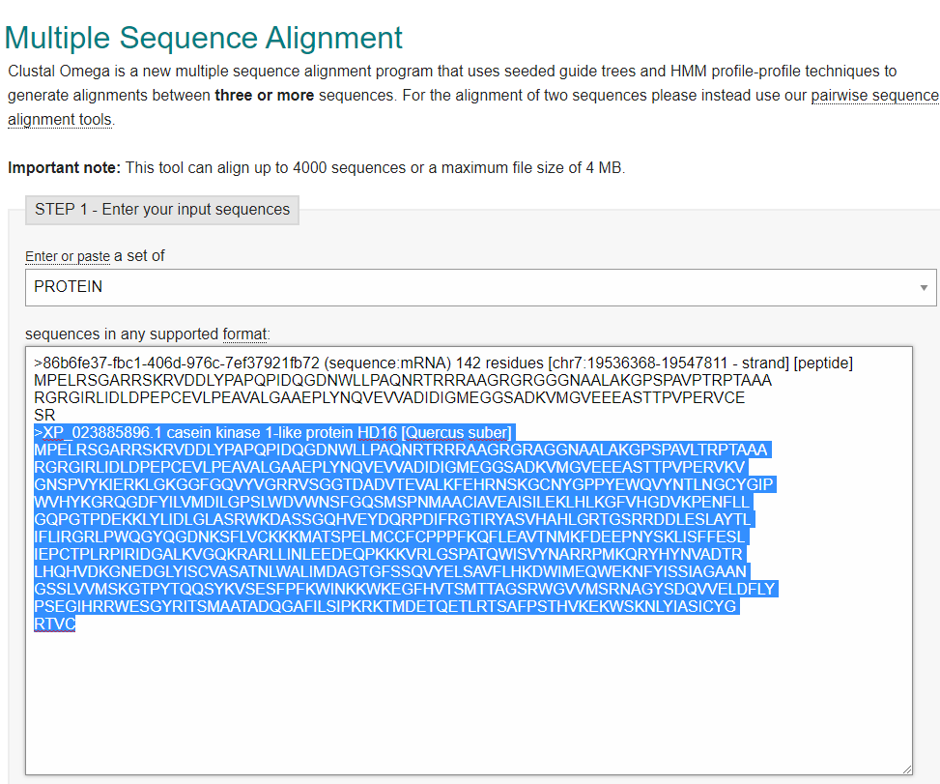

*BE SURE TO REPLACE THE TOP LINE PASTED ONLY CONTAINS THE SCIENTIFIC NAME OF SPECIES FOLLOWED BY COMMON NAME*, WITH WORDS SEPARATED BY UNDERSCORE. So that 86b6fe37 should be replaced with “Quercus_lobata”

COPY FIVE OTHER FASTA SEQUENCES THAT ARE EACH FROM **FIVE UNIQUE SPECIES** FROM THE **Sequences producing significant alignments** PAGE ONTO THE MULTIPLE SEQUENCE ALIGNMENT BOX ABOVE. (CONSISTENT WITH REQUIRED TOTAL OF SIX UNIQUE SPECIES ON CLUSTAL OMEGA PAGE).

And then click the Submit button:

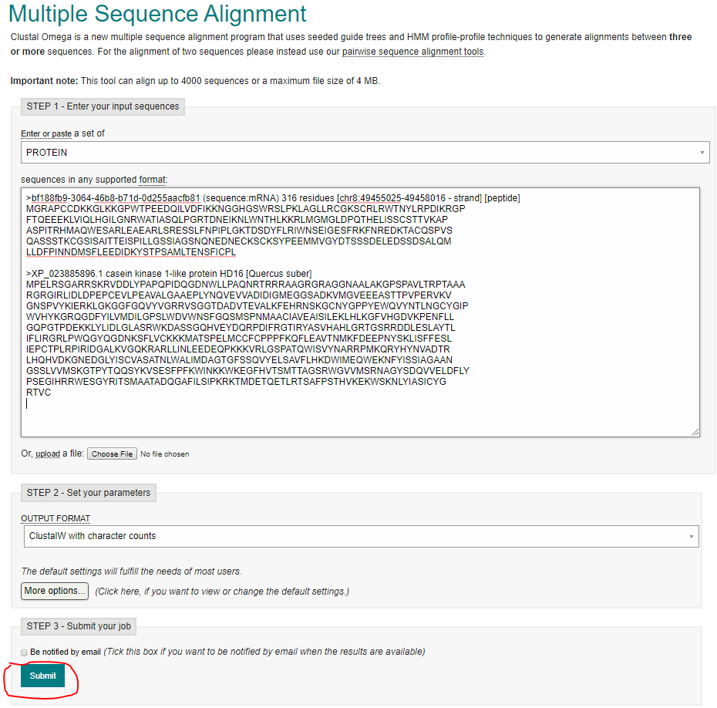

Your Clustal Omega results (hopefully) look like what is below:

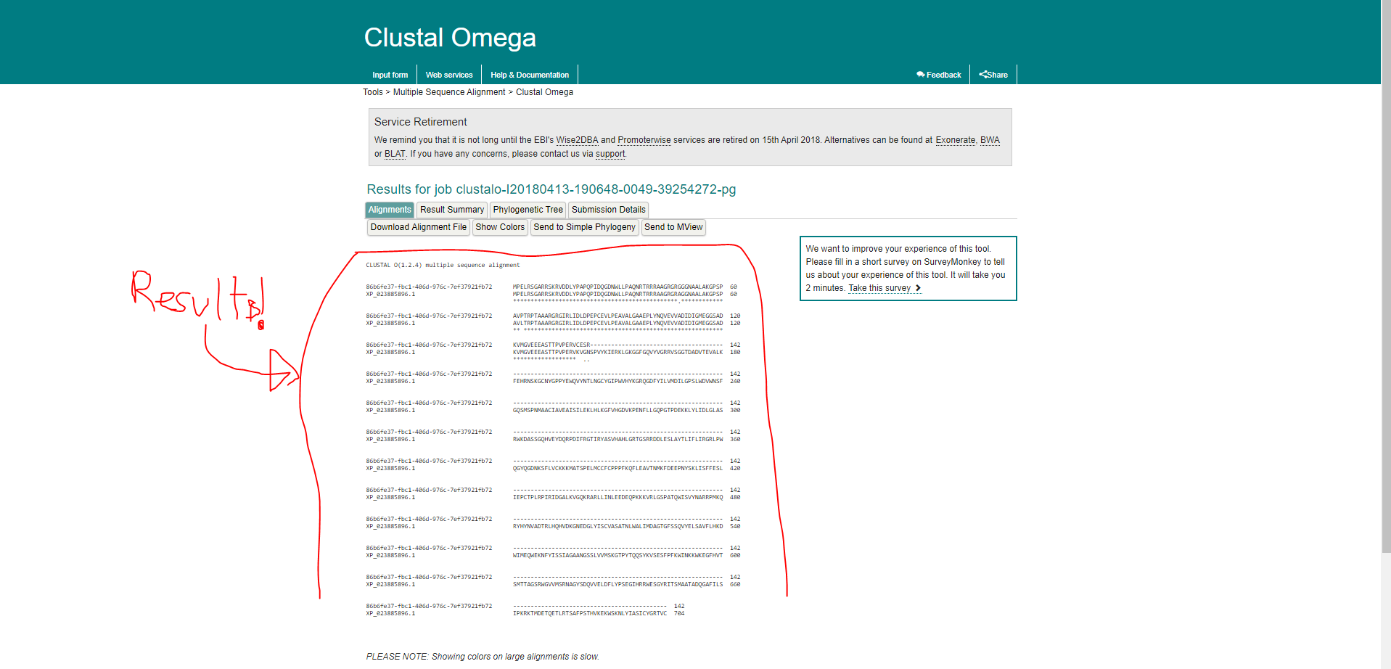

And if not you will have to paste GENOMIC SEQUENCES for each of the sequences

You are comparing INSTEAD of peptide sequences.

Now download the Multiple Sequences Alignment File and

Save it.

NOW COPY RESULTS INTO NOTEPAD AND UPLOAD THAT NOTEPAD FILE TO GITHUB.

Now take a snapshot of Phylogenetic Tree (make sure it has Species name and common name and save it to Research Data File.

Be sure to save the following:

MCDB 187AL Folder in tsalim001 AND UPLOAD IT TO GITHUB BEFORE YOU FINISH

FOR THE DAY

Structural Modeling:

Save the page.

Used to infer functionality of peptide sequences based on localization of peptide sequences?

Finish doing this to ALL OTHER GENES on the Annotations Page. You have plenty left:

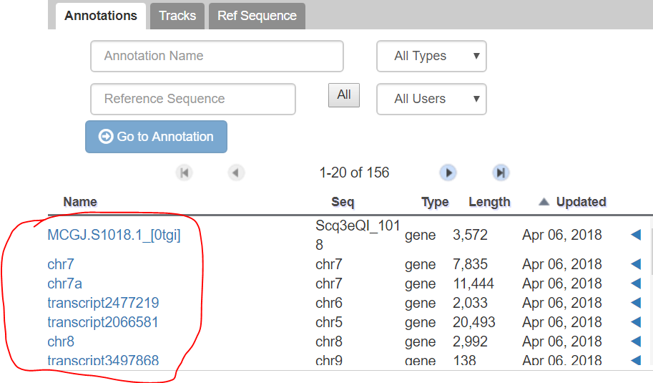

What should we present for MCDB 187AL Presentation Week 3

<https://blast.ncbi.nlm.nih.gov/Blast.cgi#alnHdr_1343964718>